**WORKING WITH DATASET**

**UNDERSTANDING THE DATASET**

|  |  |
| --- | --- |
| **TEAM ID** | PNT2022TMID08920 |
| **PROJECT NAME** | Corporate Employee Attrition Analysis |

**UNDERSTANDING THE DATASET:**

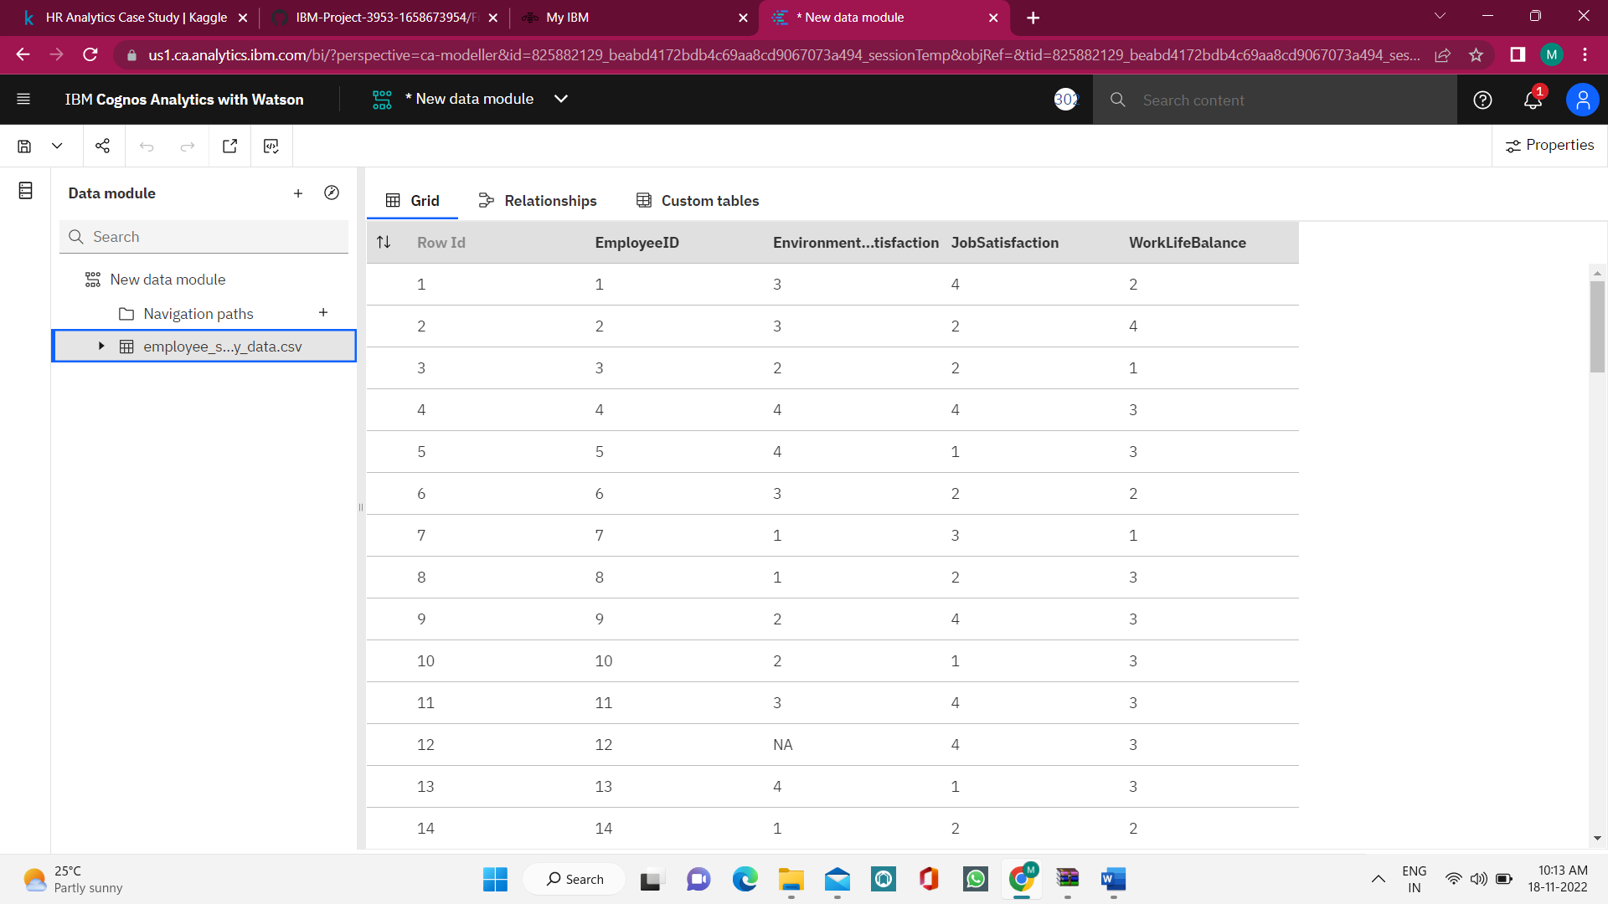 Here, the loaded dataset is understanded in order to prepare and explore the dataset.